Aim: To install MongoDB and perform basic CRUD (Create, Read, Update, Delete) operations using MongoDB tools.

Q1. What is MongoDB?
A NoSQL database that stores data in flexible, JSON-like documents, Developed by MongoDB Inc.
MongoDB is a cross-platform, open-source, database program that uses document-oriented data model. It stores data in flexible, JSON-like documents with dynamic schema, making integration easy and fast.

Q2. What is a Cluster?
A MongoDB cluster is a group of servers working together to manage and store database data. It provides high availability, scalability, and redundancy through data distribution.
Replication creates copies of data on different servers using replica sets for fault tolerance. If the primary server fails, a secondary server automatically takes over to maintain availability.

Q3. What is a Database?
A database in MongoDB is a container that holds groups of collections for organized data storage. Each database gets its own set of files on the file system.

Q4. What is a Collection?
A collection in MongoDB is a grouping of documents, analogous to a table in relational databases. It exists within a single database and does not enforce a strict schema.

Q5. What is a Document?
A document in MongoDB is a record in a collection, stored as a BSON (Binary JSON) object. It consists of field-and-value pairs, similar to JSON objects.

Q6. Steps to add/import data in MongoDB.
- Directly add documents to collections using insertOne() for single or insertMany() for multiple entries.
- Import JSON, CSV, or TSV files from the terminal using the mongoimport utility program.
- Use the intuitive graphical interface to manually add documents or drag-and-drop files for import.
- Copy data from existing collections using aggregation pipeline with $out or $merge stages.
- Insert data programmatically through official MongoDB drivers for languages like Python, Node.js, or Java.

Q6. List methods of connecting to MongoDB.
- Connect by passing a standard URI format to your MongoDB client or driver.
- Launch the command-line shell (mongosh) and specify the host and database directly.
- Establish a connection in code using official drivers like PyMongo or Node.js.
- Via MongoDB Compass GUI via a URI
Games data imported
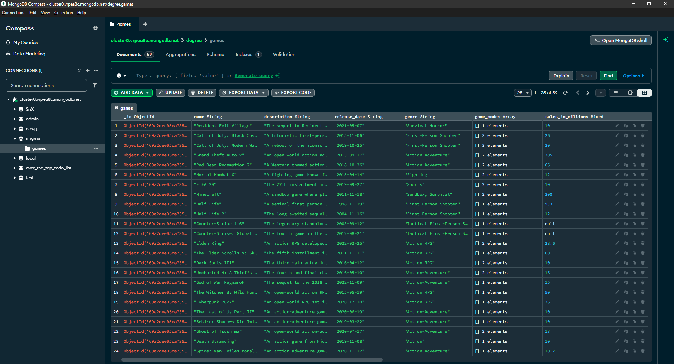

findOne(): Returns a single document that matches the specified query criteria from a collection.
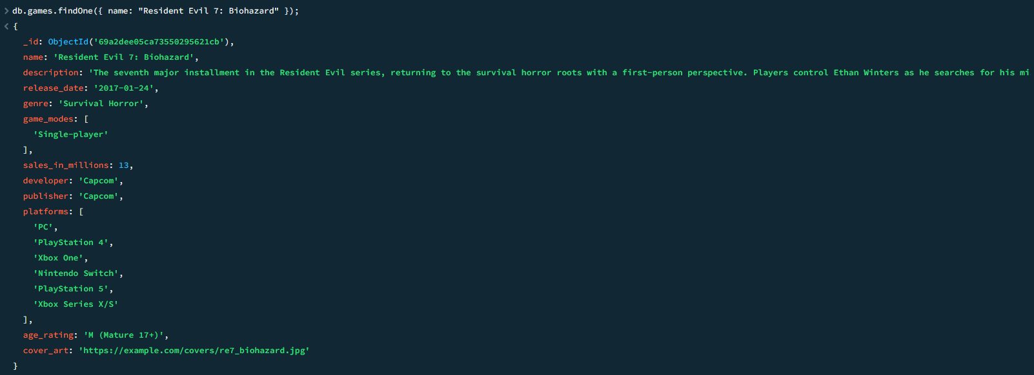

deleteOne(): Removes the first document that matches the specified filter from a collection.
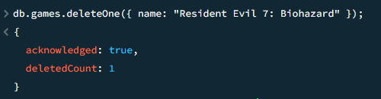
insertOne(): Adds a single new document into a collection and returns an acknowledgement.
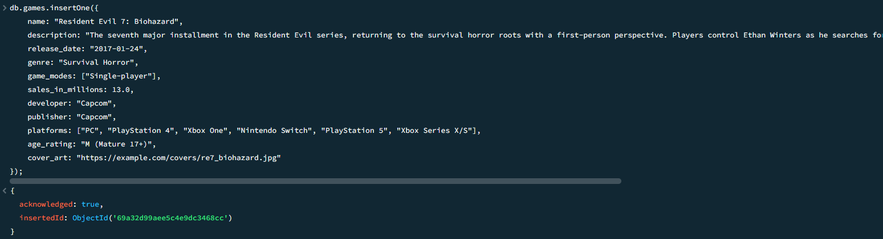

deleteMany(): Removes all documents that match the specified filter criteria from a collection.
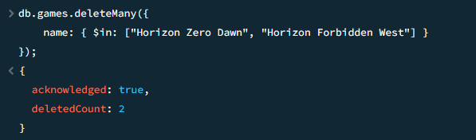

insertMany(): Inserts multiple documents into a collection in a single operation.
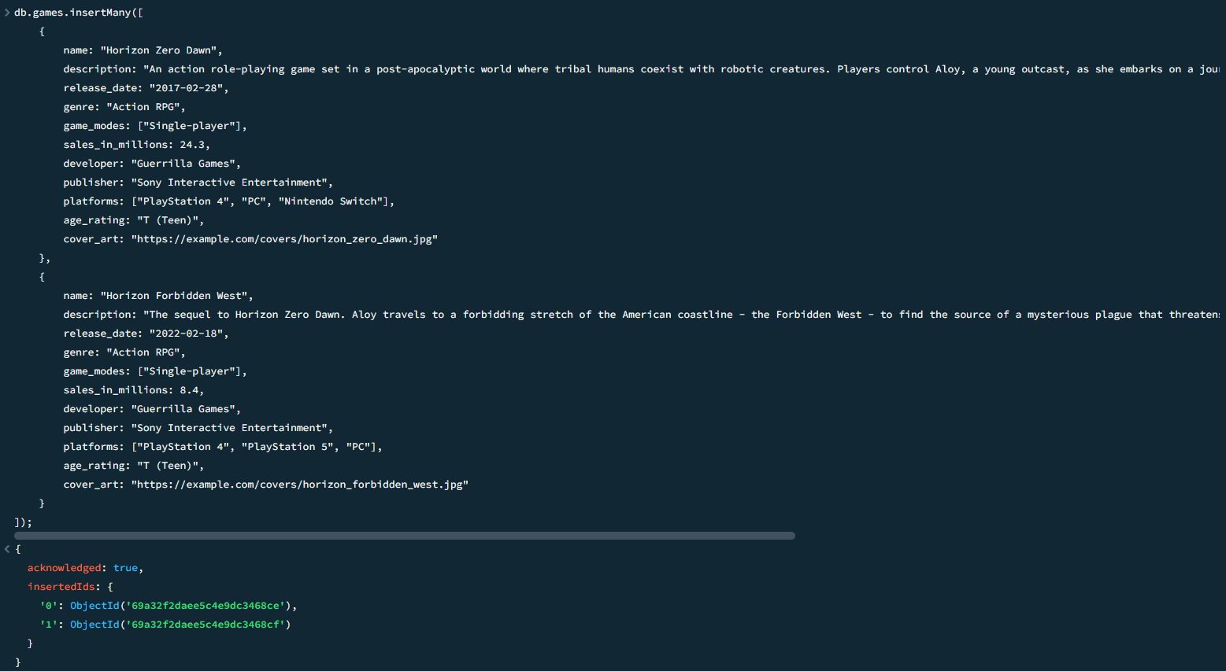
updateOne(): Modifies a single document that matches the filter criteria in a collection.
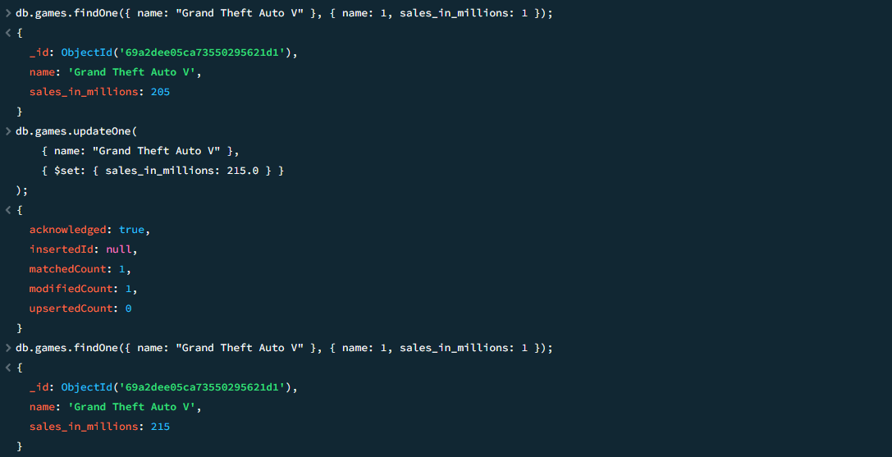

updateMany(): Updates all documents matching the specified filter criteria in a collection.
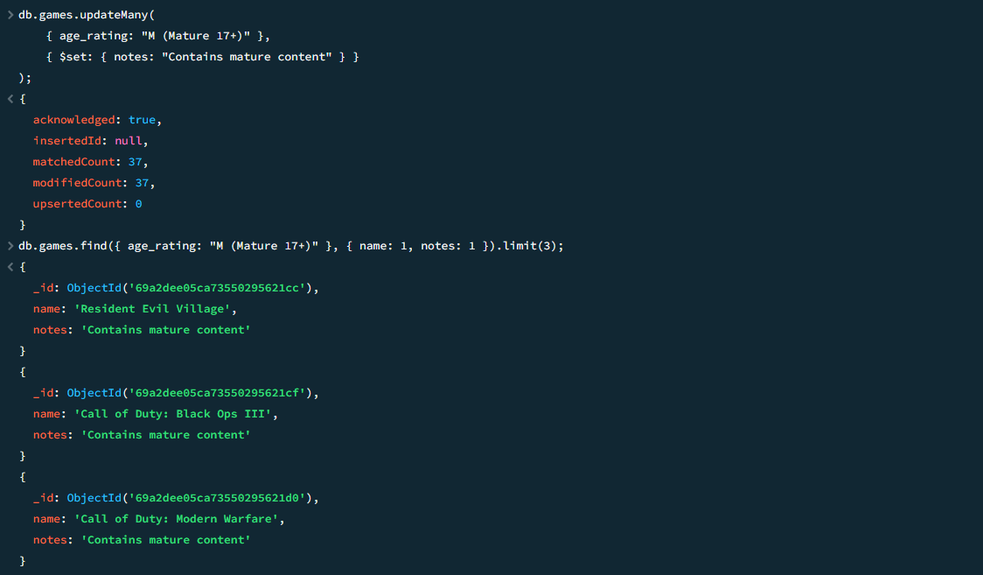

Conclusion:
Successfully installed MongoDB and demonstrated fundamental database operations through practical CRUD command execution.

